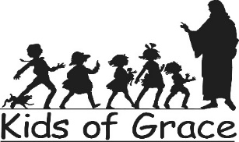
Now Enrolling 2023-24
…a part-time weekday ministry of Grace Covenant
Where children grow spiritually, emotionally, socially, and cognitively
to his/her fullest potential

Community Enrollment 2023-2024
February 1, 2023

 | Registration & Tuition Fees 2023-2024
 | Registration Fee (Non-Refundable) | Monthly Tuition
2 day 2’s | $185 | $315
2 day 3’s | $185 | $310
3 day 3’s/4’s | $185 | $380
4 day 4’s | $185 | $435
5 day 3’s/4’s | $185 | $480
Kindergarten | $235 (includes 1 time book fee) | $500

Days and Hours of Operation:

Twos: Monday/Wednesday OR Tuesday/Thursday 9:00 a.m. to 1:00 p.m.

Please be aware that in the Twos classroom, due to Building Code (USBC/IBC 305.2 and 308.5.2),
5 spots are available for children as young as 2 by September 30th (born after 3/8/19-9/30/19), the remaining 3 spots, are designated for children who are 2 ½ by the first day of school, September 8, 2022 (born on/before 3/8/20).

Threes: Monday/Wednesday/Friday OR Tuesday/Thursday 9:00 a.m. to 1:00 p.m.
OR Monday - Friday

Fours: Monday/Wednesday/Friday OR Monday-Thursday OR Monday-Friday
9:00 a.m. to 1:00 p.m.

Kindergarten: Monday - Friday 9:00 a.m. to 1:00 p.m.

Kids of Grace Preschool & Kindergarten

(757) 689-2009 kidsofgrace@gcpcpa.org www.kidsofgracepreschool.org

